

 འབྲུག་རྒྱལ་འཛནི་གཙུག་ལག་སབློ ་ས།ྡེ །

College of Science and Technology
Rinchending: Bhutan

DSO101
Database Systems Fundamentals
(SS2026)

Practical 1 Report

Submitted By;
Name: Pelden Nidup
Student No.: 02250360
Programme: BE 1SWE
Date:

RUB Wheel of Academic Law: Academic Dishonesty
Section H2 of the Royal University of Bhutan’s Wheel of Academic Law provides the following definition of academic dishonesty:

Academic dishonesty may be defined as any attempt by a student to gain an unfair advantage in any assessment. It may be demonstrated by one of the following:
- Collusion: the representation of a piece of unauthorised group work as the work of a single candidate.
- Commissioning: submitting an assignment done by another person as the student’s own work.
- Duplication: the inclusion in coursework of material identical or substantially similar to material which has already been submitted for any other assessment within the University.
- False declaration: making a false declaration to receive special consideration by an Examination Board or to obtain extensions to deadlines or exemption from work.
- Falsification of data: presentation of data in laboratory reports, projects, etc., based on work purported to have been carried out by the student, which has been invented, altered or copied by the student.
- Plagiarism: the unacknowledged use of another’s work as if it were one’s own.
Examples are:
- verbatim copying of another’s work without acknowledgement.
- paraphrasing of another’s work by simply changing a few words or altering the order of presentation, without acknowledgement.
- ideas or intellectual data in any form presented as one’s own without acknowledging the source(s).
- making significant use of unattributed digital images such as graphs, tables, photographs, etc., taken from test books, articles, films, plays, handouts, the internet, or any other source, whether published or unpublished.
- submission of a piece of work which has previously been assessed for a different award or module or at a different institution as if it were new work.
- use of any material without prior permission of copyright from the appropriate authority or owner of the materials used”.

1. Introduction.
This lab focuses on building and deploying a full-stack To-Do List application using Continuous Integration and Continuous Deployment (CI/CD) practices. The system includes a frontend, backend API, and a database. All components are containerized using Docker and deployed using Render.
The main purpose of this lab is to understand how modern web applications are developed, containerized, and automatically deployed using cloud services and version control systems like GitHub.

2. Aim.
The aim of this lab is to design, build, containerize, and deploy a full-stack To-Do List application using Docker and Render. It also focuses on using environment variables and implementing automated deployment workflows.

3. Tools and Technologies Used.
- Frontend: React (or any chosen framework).
- Backend: Node.js and Express.
- Database: PostgreSQL (Render managed database).
- Containerization: Docker.
- Cloud Platform: Render.com.
- Version Control: GitHub.
- Environment Management: .env files.

4. Step 0: Creating the To-Do Application.

4.1 Features Implemented.
The application includes the following features.

Frontend (FE).
The frontend provides a simple user interface where users can add new tasks, edit existing tasks, delete tasks, and view all tasks. It is designed to be clean and easy to use.
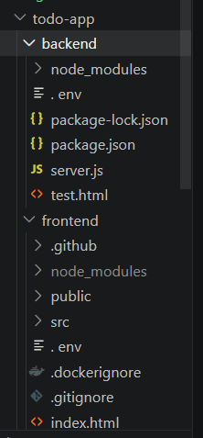
Backend (BE).
The backend handles all the logic of the application. It is built using REST API principles and connects the frontend with the database. It supports full CRUD operations, which means users can create, read, update, and delete tasks.
The API endpoints used are:
- POST /tasks (to add a new task).
- GET /tasks (to get all tasks).
- PUT /tasks/:id (to update a task).
- DELETE /tasks/:id (to remove a task).

Database (DB).
PostgreSQL is used as the database to store all tasks. It ensures that data is saved permanently and does not disappear when the server restarts. Each task is stored in a table with fields like ID, title, and status.

4.2 Environment Variables Setup.
Environment variables are used to store sensitive and environment-specific data. This makes the application more secure and flexible.
Backend .env file.
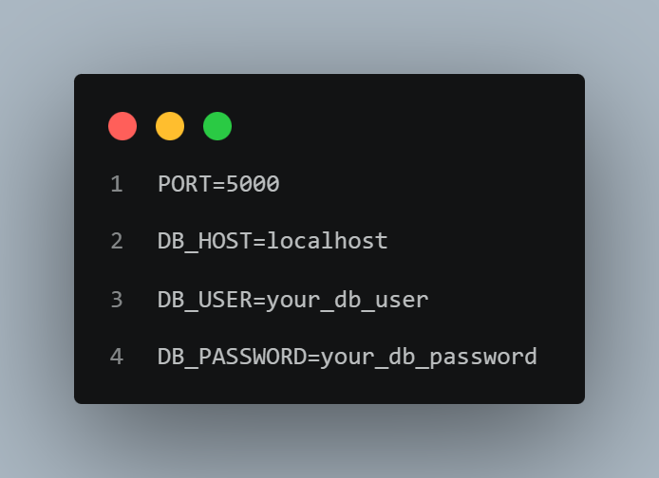

Frontend .env.production file.
REACT_APP_API_URL=be-todo:02250360 ・ Web Service ・ Render Dashboard
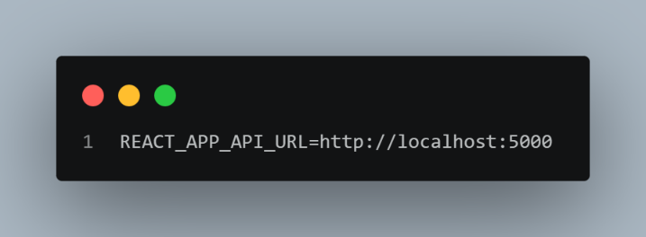

The .env file is added to .gitignore so that it is never pushed to GitHub for security reasons.
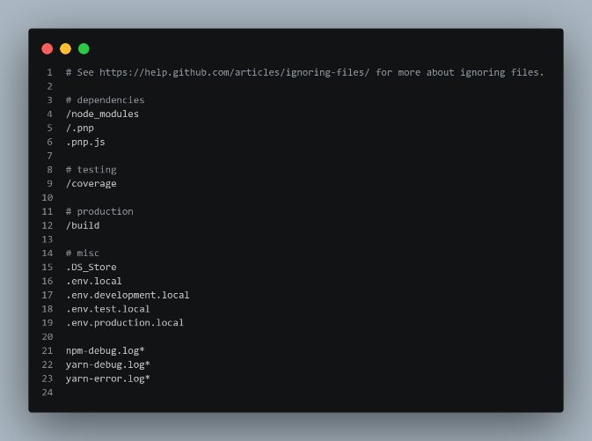

5.1 Backend Dockerfile.
The backend is containerized using Docker so it can run in any environment without issues.
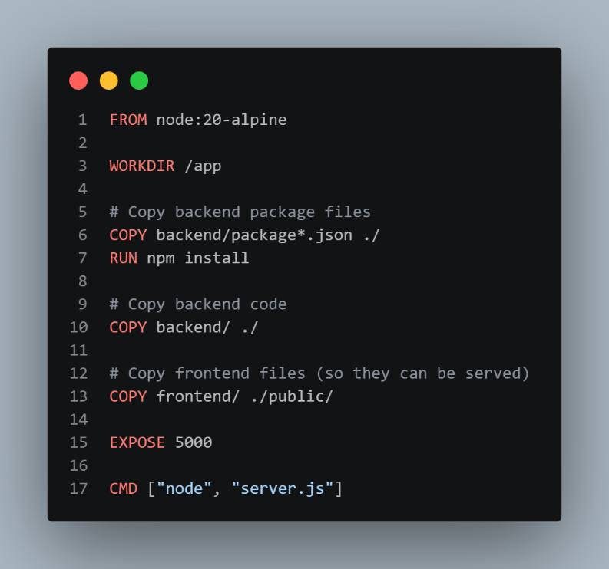

5.2 Building the Docker Image.
The following command was used to build the backend image.
docker build -t yourdockerhub/be-todo:02250360 ..
This command creates a Docker image of the backend application using the student ID as the tag.

5.3 After building the image, it was pushed to Docker Hub using the following command.
docker push yourdockerhub/be-todo:02250360.
This ensures the image is available in the cloud registry for deployment on Render.
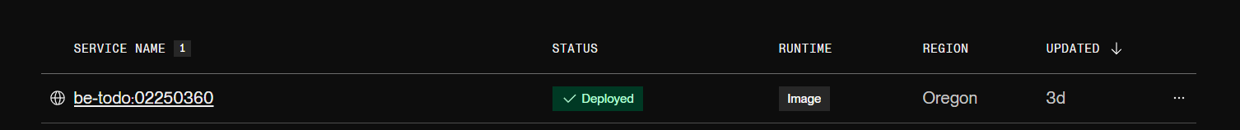

5.3 Backend Deployment on Render.
The backend service is deployed on Render using the Docker Hub image.


5.5 Frontend Deployment.
The frontend is also deployed using Docker and connected to the backend using the API URL.
REACT_APP_API_URL=https://be-todo.onrender.com.

5.6 Database Setup.
PostgreSQL (managed by Render) is used as the database. It stores all tasks permanently and ensures data persistence even after redeployment. The backend connects to this database using environment variables.
6. Part B: Automated CI/CD Deployment.
6.1 Project Structure.
The project is organized in a simple structure to separate frontend, backend, and deployment configuration.
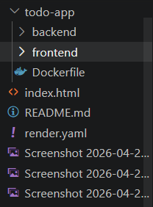
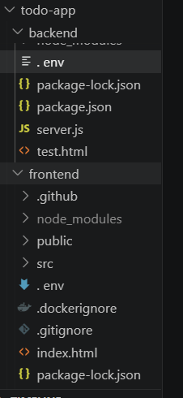

6.2 render.yaml Configuration.
The render.yaml file is used to automate deployment for both frontend and backend services. It works like a blueprint for Render.
services:
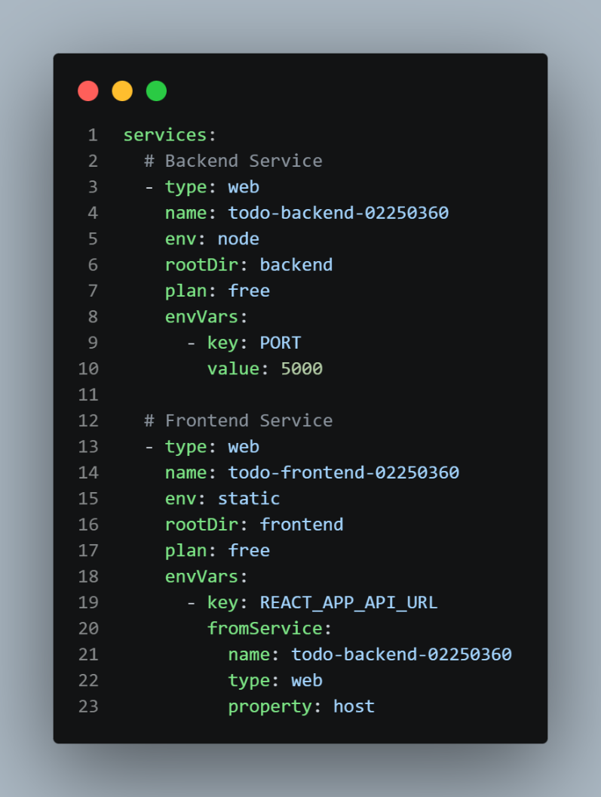
6.3 CI/CD Workflow.
The project is connected to GitHub and Render. Every time a new commit is pushed to GitHub, Render automatically rebuilds and redeploys the application.
This means developers do not need to manually deploy the application again and again. Everything happens automatically, which saves time and reduces errors.

7. Results.
The application was successfully built and deployed. The frontend works smoothly with the backend API. The backend is fully connected to the PostgreSQL database. Docker ensures consistency across environments. The CI/CD pipeline automatically deploys updates whenever code changes are pushed.

8. Conclusion.
This lab helped in understanding how a full-stack application is developed and deployed in real-world scenarios. Docker made it easy to package the application, while Render helped deploy it on the cloud. CI/CD automation improved the development process by removing manual deployment steps.
Overall, this lab provided a clear understanding of modern software development practices and how different tools work together in a real project.

